Looking through Each Other’s Eyes
Catholic Charities 2015 Annual Appeal theme this Mother’s Day May 9th and 10th calls for you and me to Replace Heartache with Hope by Looking through each Other’s Eyes.
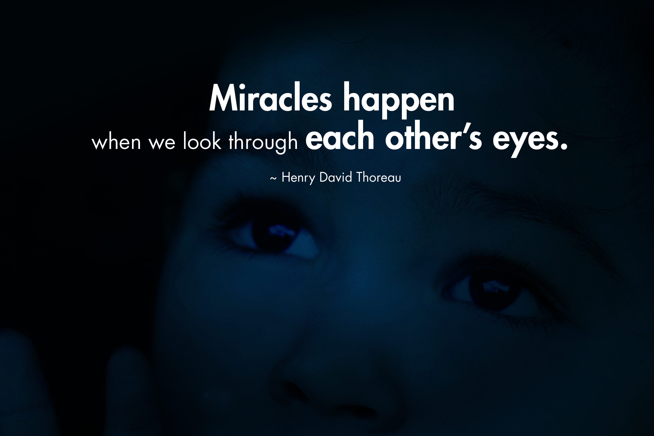
Pope Francis reminded us recently that we have in many ways created a “throw away” culture. It is no longer simply about exploitation and oppression. Those excluded are now seen as “leftovers.” He asked us to open our eyes to those who are suffering; the heartbroken, the marginalized, the poor and those excluded who feel like outcasts. When we look through each other’s eyes and respond with compassion.. miracles happen. You become the instrument of God’s grace and healing transformation. At Catholic Charities we replace heartache with hope by looking through each other’s eyes. We see the “image of God” in the eyes of each person we serve. No one should feel like a “leftover” or be “excluded” from God’s love. Your support of our efforts affirms to those on the margins that they are valued. It is your compassion and generosity that allows us to replace heartache with hope for:
- The expectant teen mother feeling like an outcast and having nowhere to turn who tearfully called our 24/7/365 hotline to confide her feelings of despair to a caseworker. She was provided with compassionate support and hope for her future and the future of her unborn child.
- The refugee father who arrived after suffering the devastation of war; longing for his children to grow up in a peaceful environment. Hope was provided with stable housing, medical access, English classes, financial literacy training, and bus orientations. Dad now has a full-time job that supports his family and his children are thriving in school.

- The widowed senior woman who could no longer afford her medication and turned to our MediApps caseworker. She now has her prescription and the hope that comes with restored health.
What we accomplish is really what you accomplish through us. You are the instrument of God’s grace and healing transformation.
Your generous support of Catholic Charities Annual Appeal on Mother’s Day weekend, May 9th and 10th helps children in need, families in crisis, vulnerable adults and seniors, refugees and immigrants, unmarried mothers and their unborn children reach their full potential, regardless of race, faith tradition or ability to pay.
Replace heartache with hope this Mother’s Day weekend by looking through each other’s eyes. A miracle of transformation is created for both the giver and the receiver when we open our eyes to those who are suffering and respond compassionately. Thoreau’s thought provoking quote inspires you and me, “Could a great miracle take place than for us to look through each other’s eyes for an instant?” ~Henry David Thoreau
Your generosity and committed support of our mission is life changing for the poor and marginalized in our diocese. We are ever mindful that lives are transformed and hope renewed because of you! God bless you for your compassion and kindness on behalf of those we serve.

Mary Alessio
Director of Advancement
Catholic Charities Diocese of Winona

